Exp 12: VMware Workstation — Install Type-2 Hypervisor & Create a VM (1 CPU, 2 GB RAM, 15 GB disk)

Aim
Demonstrate Type-2 virtualization by installing VMware Workstation and creating a VM (Windows or Linux) with 1 vCPU, 2 GB RAM, and a 15 GB virtual disk.
Procedure
- Install VMware Workstation (Pro/Player) on the host OS and launch it.
- Create a New Virtual Machine → Typical → choose installer ISO (Windows/Linux) or OS later.
- Select Guest OS type/version (e.g., Linux → Ubuntu 64-bit or Windows 10/11).
- Set Disk: create a 15 GB virtual disk (single file or split).
- Customize Hardware… → set Memory = 2048 MB, Processors = 1, attach ISO to CD/DVD.
- Finish & Power on → complete guest OS installation wizard
Output

Figure 1 Virtual Machine with 1 CPU, 2 GB RAM, and 15 GB storage
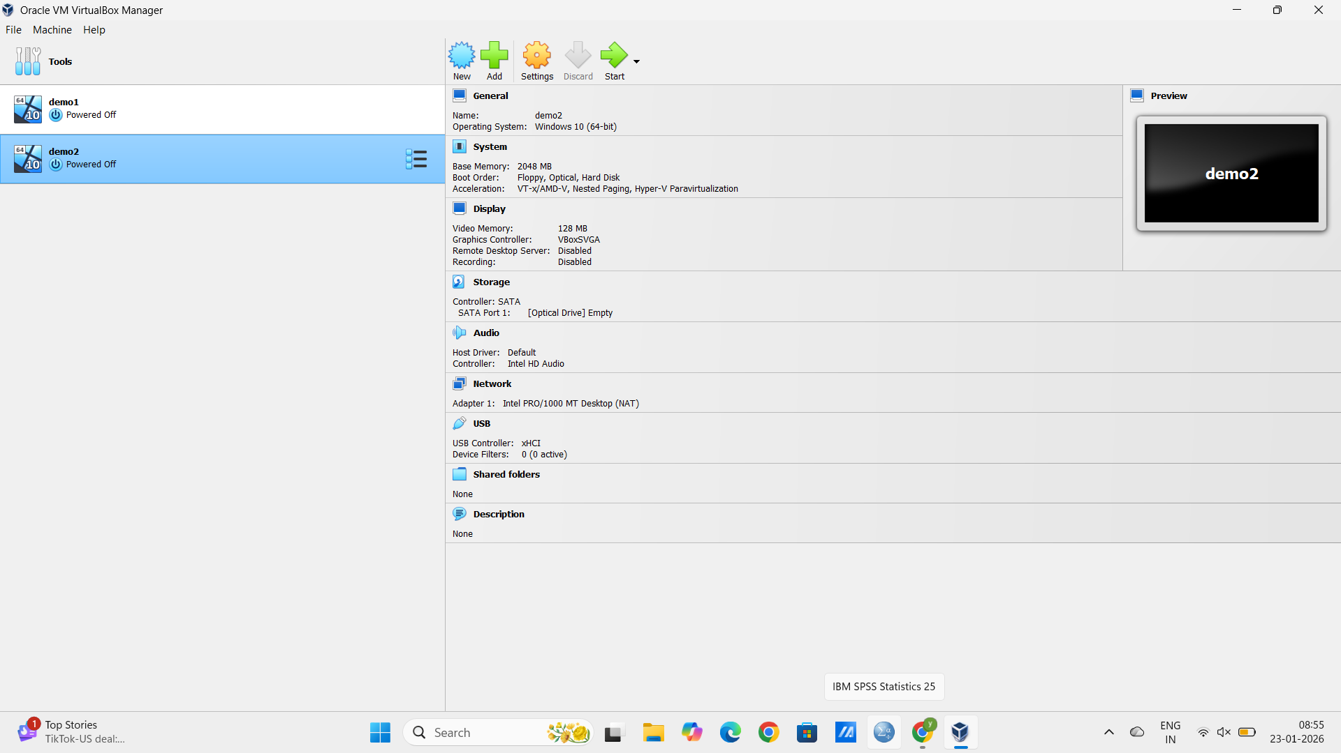

Result
A working VM on VMware Workstation with the specified CPU/RAM/disk, successfully booting into the installed guest OS

